DISTRICT GIS PARAKH
परख
Two-Factor Authentication (2FA) — Setup Guide
Mandatory Mobile Number Verification for all District & Department-Level Logins

 | All District GIS Parakh users — Citizen, Vendor/Agency, and Department logins (Web Portal)
Portal URL | https://geoportal.mp.gov.in/parakhweb/
Requirement | Mandatory as per Government of Madhya Pradesh guidelines at the state level
Timeline | All users must complete mobile number verification within the coming week

This guide walks every District GIS Parakh user through verifying their mobile number for Two-Factor Authentication (2FA). Once completed, an OTP sent to your registered mobile number will be required as a second layer of login security, in addition to your username and password.

Overview
Two-Factor Authentication (2FA) adds a second layer of verification — a One-Time Password (OTP) sent to your registered mobile number — on top of your existing username and password. This protects District GIS Parakh accounts against unauthorized access, in line with Government of Madhya Pradesh security guidelines applicable to all state-level e-Governance platforms.

Who needs to do this?
- Every user who logs into the District GIS Parakh Web Portal — Citizen, Vendor/Agency, and Department logins alike.
- This applies across all districts and all departments currently onboarded on Parakh.

What you will need
- Your existing Parakh Username and Password.
- Access to the mobile number you want registered for 2FA — you will receive an OTP on this number.
Before you begin: Mobile number verification is mandatory for all users and cannot be skipped. If your registered mobile number is incorrect or no longer in use, update it to a number you will continue to use going forward, since this is the number your OTPs will be sent to for every future login.

Step-by-Step: Verifying Your Mobile Number
1 | Log in to Parakh through your web browser

Open the Parakh Web Portal in your browser and select the Department tile (Citizen and Vendor/Agency users should select their respective tile).
Production URL:
https://geoportal.mp.gov.in/parakhweb/
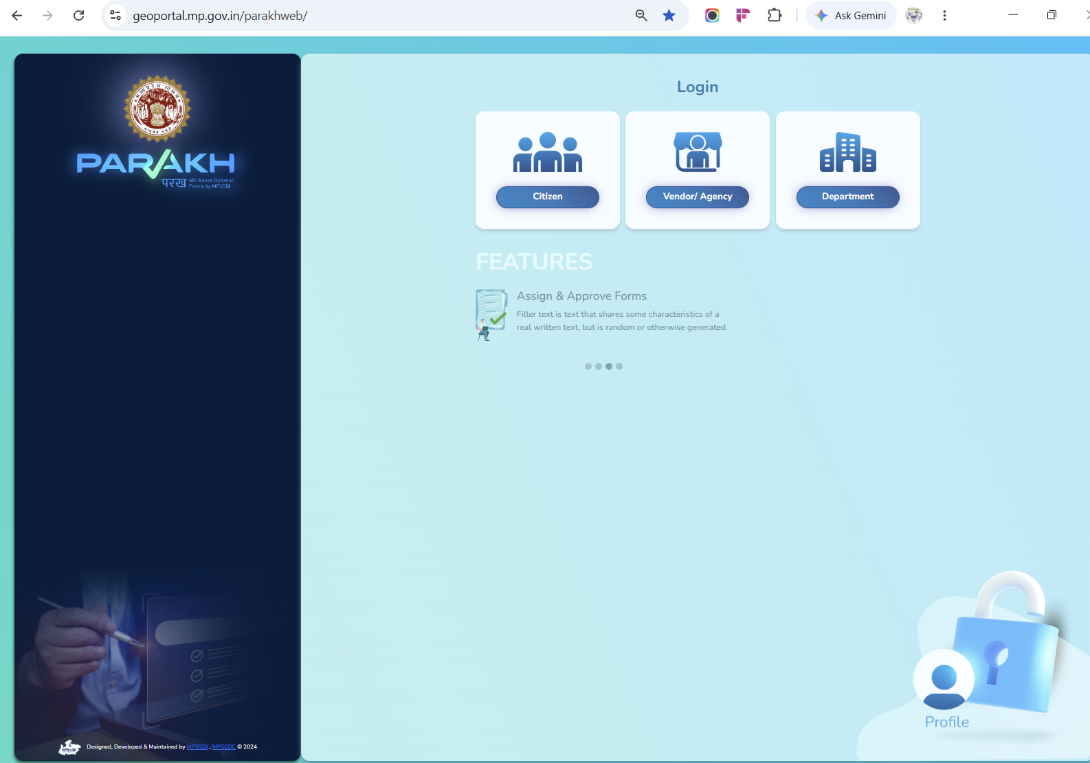
Parakh Web Portal login landing page — select Citizen, Vendor/Agency, or Department
Enter your existing Username and Password in the Department Login window and click Login.
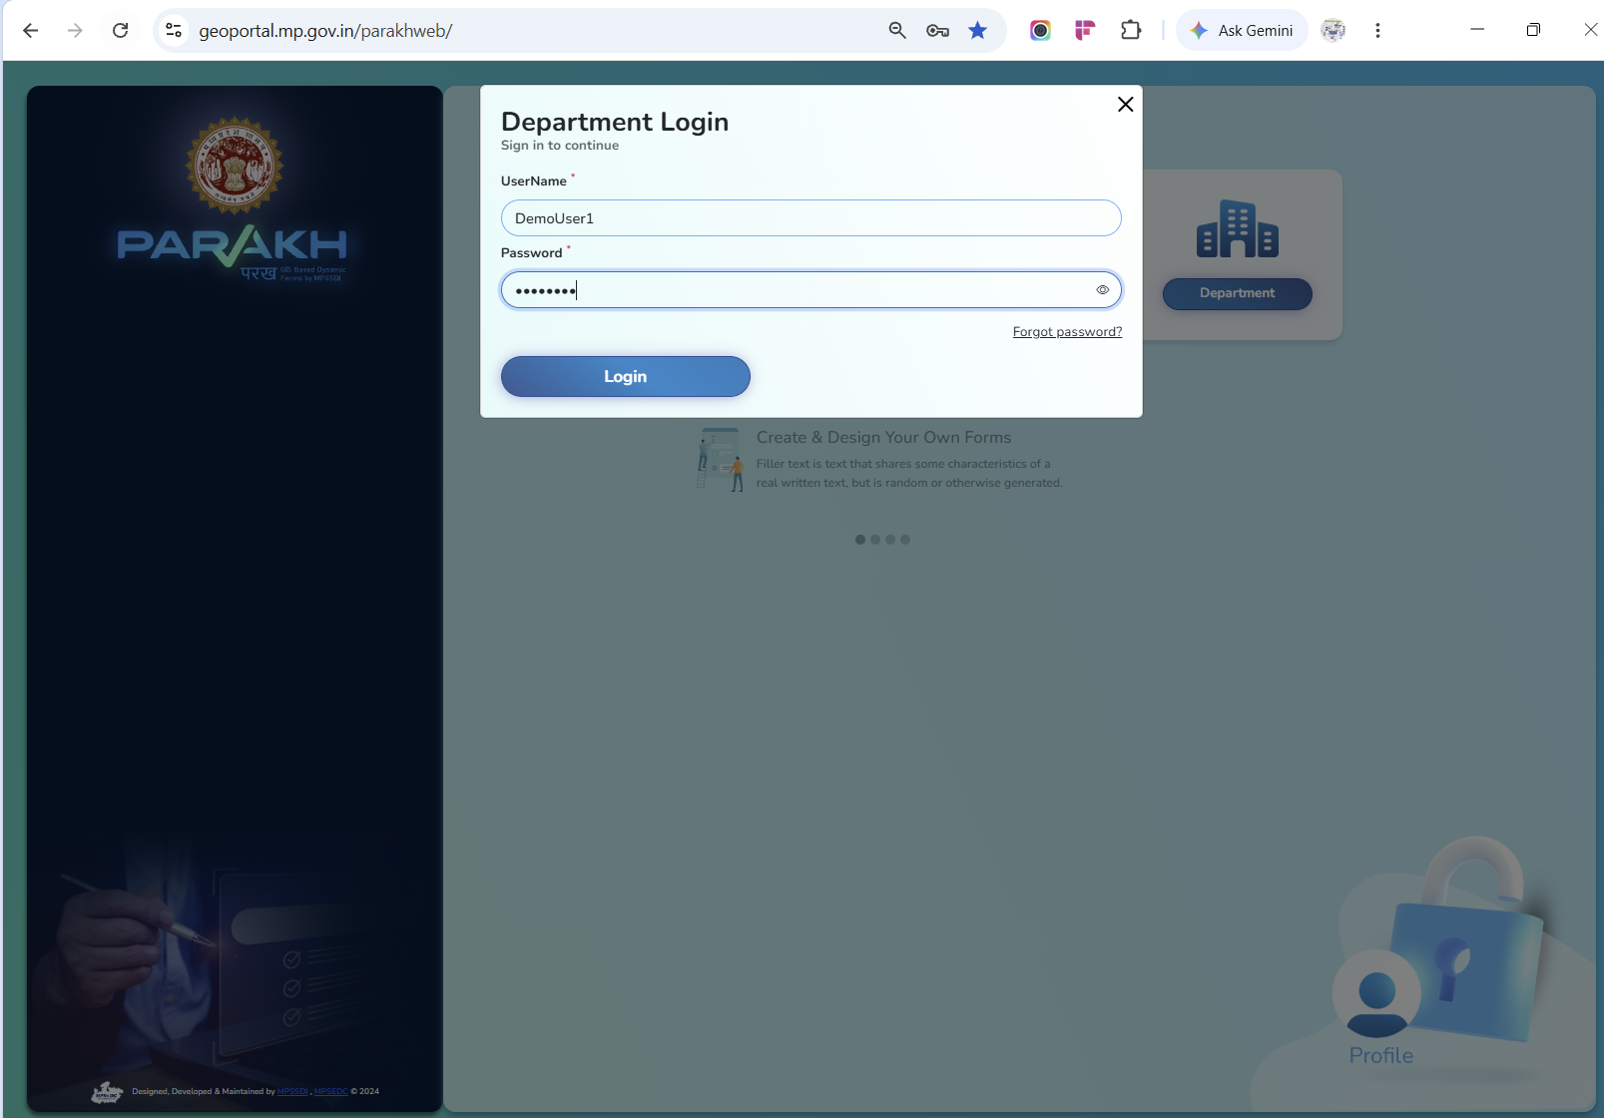
Department Login — enter your Username and Password
2 | Confirm the mobile-verification prompt

After logging in, Parakh will display a notice confirming that your mobile number is not yet verified and that verification is mandatory for all users. Click OK to proceed.
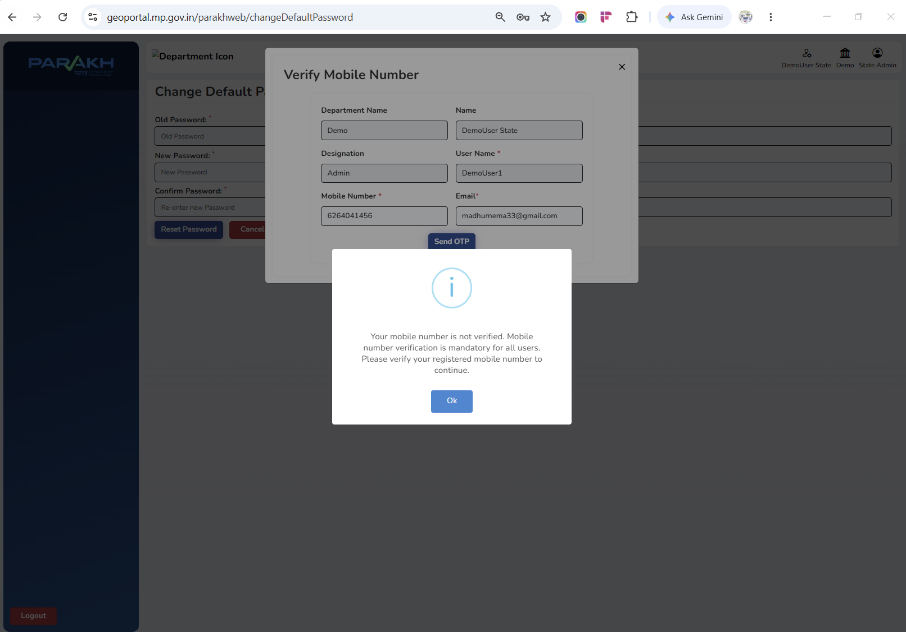
Mandatory notice — mobile number verification required to continue
3 | Review your details and send the OTP

The Verify Mobile Number window opens with your Department Name, Name, Designation, User Name, Mobile Number, and Email pre-filled from your profile.
- Check the Mobile Number field carefully — this is the number that will receive your login OTP going forward.
- If it needs to be updated, correct it here before proceeding.
- Once confirmed, click Send OTP.
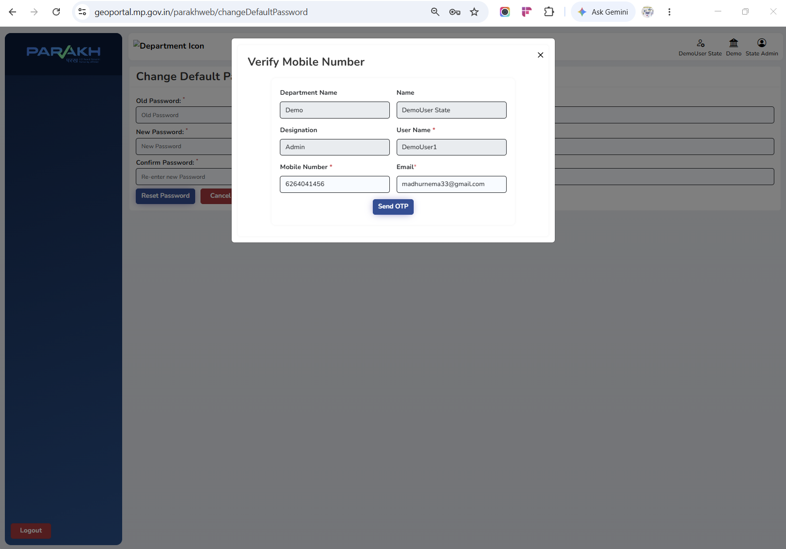
Verify Mobile Number — confirm your details and click Send OTP
A confirmation message will appear once the OTP has been sent successfully.
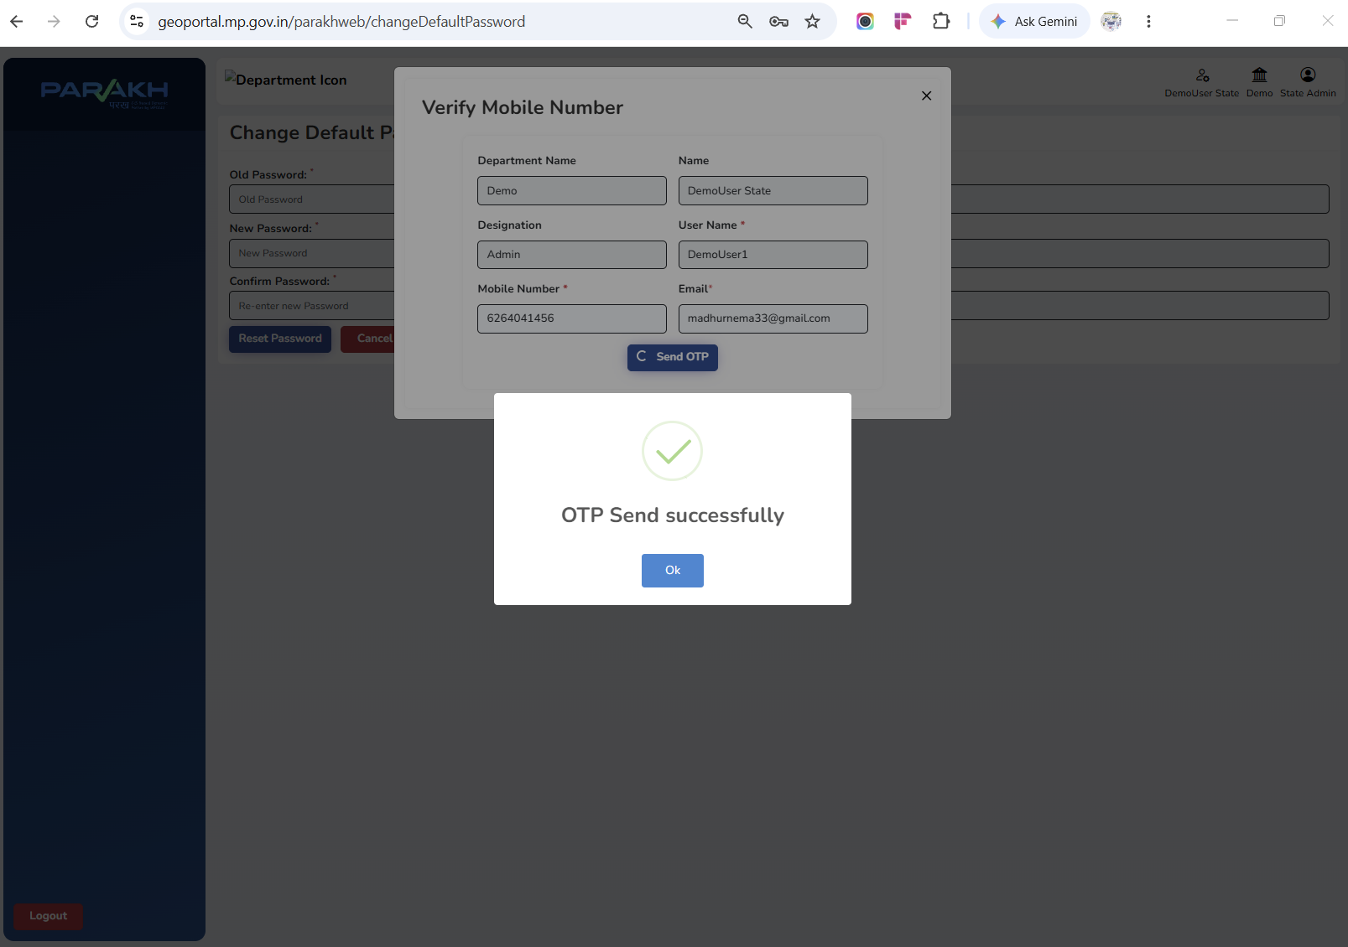
Confirmation — OTP sent successfully to your registered mobile number
4 | Enter the OTP and verify

You will receive a 4-digit OTP by SMS on the mobile number shown on screen. Enter the OTP in the boxes provided and click Verify OTP.
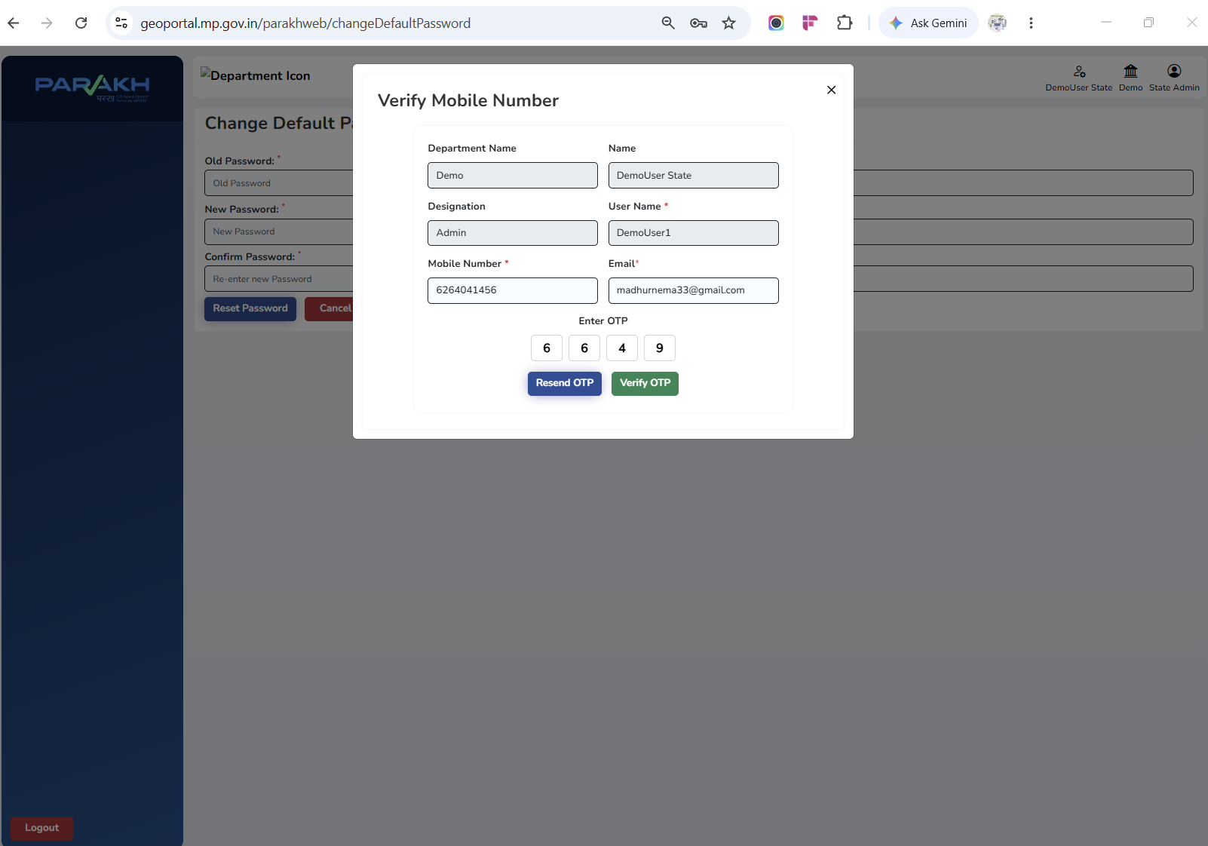
Enter the OTP received on your mobile number, then click Verify OTP
Important: The OTP is valid for 10 minutes from the time it is sent. If it expires before you enter it, click Resend OTP to receive a new one.
5 | Confirmation — 2FA is now enabled

Once the OTP is verified, Parakh confirms that your contact details have been updated successfully. Your mobile number is now registered for Two-Factor Authentication, and you will be asked for an OTP on this number at future logins.
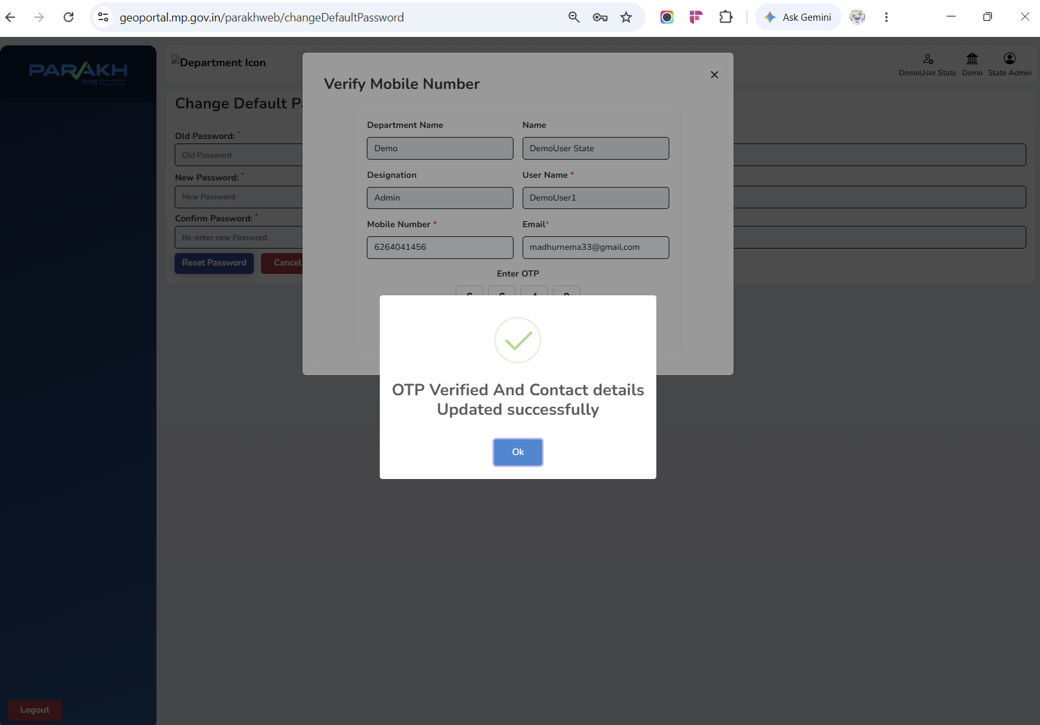
OTP verified — contact details updated and 2FA enabled successfully

Important Notes
- Mobile number verification is mandatory for every District GIS Parakh user and is required under Government of Madhya Pradesh guidelines at the state level — it cannot be deferred or skipped.
- All users are expected to complete this verification within the coming week.
- The OTP sent during verification (and at every future login) is valid for 10 minutes only.
- Make sure the mobile number you register is one you will continue to have access to, since it becomes your permanent 2FA number for all future logins.
- If you do not receive the OTP, use the Resend OTP option before contacting support.

Need Help?
If you face any issue while verifying your mobile number or completing 2FA setup, please reach out to the District GIS Parakh support team through your usual GIS Data Specialist / District GIS Executive point of contact.

